Name: Sanika Botre PRN: 25070122063
Batch: 2025-29 Branch: CSE A-2
Subject: Programming with Java

ASSIGNMENT No: 7

TITLE : Implement a Java program to demonstrate inheritance and interfaces using suitable real-world examples.

Problem Statement: Implement a Java program to demonstrate inheritance and interfaces using suitable realworld examples.

Learning Objectives: To implement inheritance and interfaces for achieving code reusability and abstraction.

Theory:

Inheritance allows one class to acquire the properties and methods of another class, promoting code reuse and reducing redundancy. Java supports single inheritance through the extends keyword. Interfaces define a contract that implementing classes must follow, enabling abstraction and multiple inheritance of type. Together, inheritance and interfaces support polymorphism and modular software development. They are fundamental concepts of object-oriented programming.

Exercise:

1. Create a Shape application where Circle and Rectangle inherit from Shape and calculate area.

Code:-

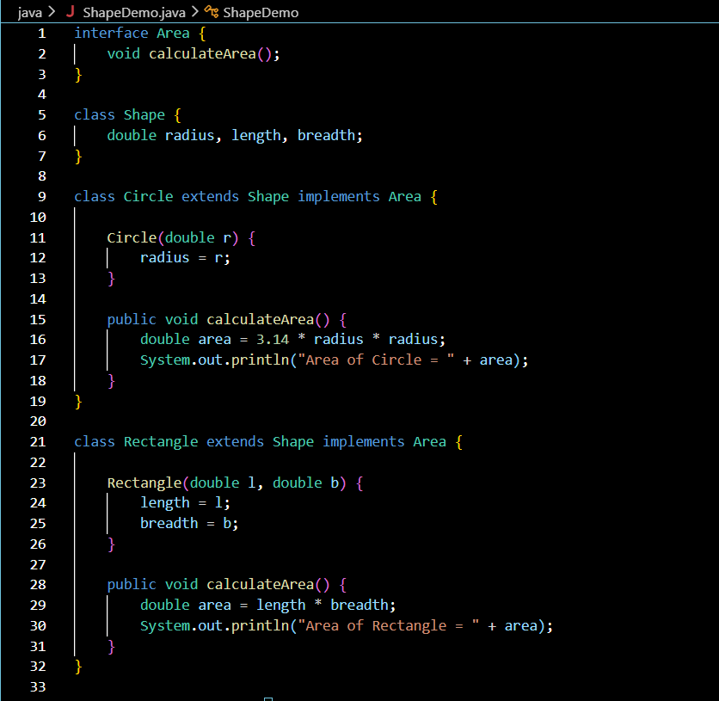

Output:-

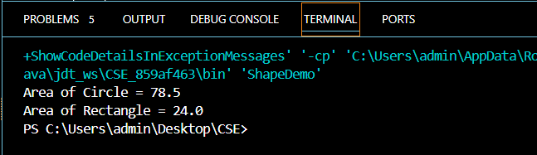

2. Develop a E-Commerce Product System where electronic, clothing, and grocery products inherit common properties and implement product interfaces.

Code:-

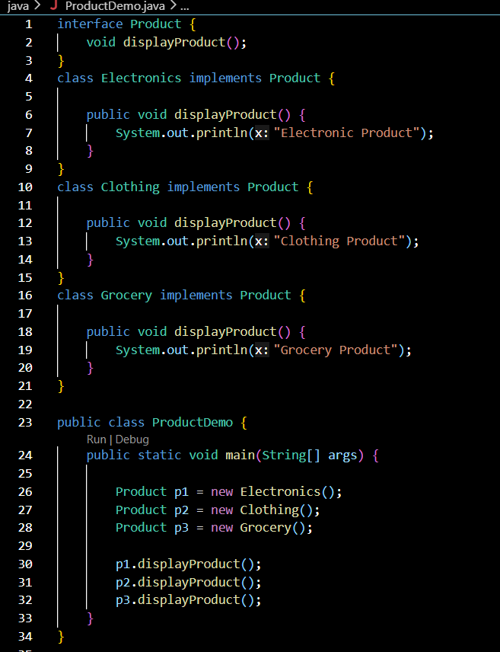

Output:-



Conclusion:

This assignment successfully demonstrated the concepts of inheritance and interfaces in Java. The programs showed how inheritance promotes code reusability by allowing a class to acquire the properties of another class, while interfaces provide abstraction and support multiple implementations of common behavior. The applications executed successfully and produced the expected results. Overall, this assignment enhanced the understanding of object-oriented programming principles and their practical implementation in Java.

